Preparing for new dam safety responsibilities
The new regulations on dam safety come into force on 13 May 2024.
The regulations have been made to increase the resilience and safety of Aotearoa/New Zealand’s dams, protecting people, property and the environment from the potential impacts of dam failures. They also provide a nationally consistent risk-based approach to dam safety.
Why the regulations have been made
The regulations were made in May 2022 and ensure dams that meet a certain height and volume threshold are well operated, maintained and regularly monitored. They also ensure that potential risks of dam incidents and failures are reduced.
Until the regulations were made, Aotearoa/New Zealand was one of the few countries in the Organisation for Economic Co-operation and Development (OECD) that did not have a consistent regulatory dam safety framework.
Find out more information about the regulations – Building Performance
Take action now to prepare for the new regulations
Owners of dams should prepare for the new regulations before they commence on 13 May 2024. Dam owners first need to determine if their dam is impacted by the regulations.
A dam is impacted if it is four or more metres in height and stores 20,000 or more cubic metres volume of water, or other fluid.
If a dam impacted, the dam owner will need to become familiar with their responsibilities under the regulations. These responsibilities include assessing their dam’s potential impact on the community, historical or cultural places, critical or major infrastructure and the natural environment, should their dam fail.
Other responsibilities will vary depending on the outcome of the assessment. Owners of dams assessed as having a lower potential impact on the surrounding area will have fewer responsibilities, whereas those with higher potential impacts will have more responsibilities.
Learn more about the responsibilities – Building Performance
Engaging a Recognised Engineer
Under the regulations, engineers will be registered to audit and certify potential impact classifications and dam safety assurance programmes. These registered engineers are called Recognised Engineers.
Dam owners whose dams are impacted by the regulations will need to engage a Recognised Engineer.
Engineering New Zealand Te Ao Rangahau, as the Registration Authority for Chartered Professional Engineers, is responsible for assessing and registering recognised engineers. Together with the New Zealand Society on Large Dams (NZSOLD), they have developed the framework and registration process for recognised engineer qualifications and competencies.
Further information is available on Engineering New Zealand Te Ao Rangahau’s website:
Find out more about Recognised Engineers.
Tips for engaging an engineer.

Resources to support dam owners
Further information and resources are available on MBIE’s Building Performance website to help dam owners understand and prepare for the regulations. This includes a detailed guidance document and a resource to help dam owners calculate the height and volume of their dam themselves, which in turn helps them understand if their dam is impacted by the regulations. Three form templates, which list the information dam owners must provide to regional authorities, are also available.

Find out more information about the regulations – Building Performance
Access the resources – Building Performance

The New Zealand Society of Large Dams (NZSOLD) are currently updating their industry Dam Safety Guidelines to reflect the new regulations.
Dam Safety Guidelines (2015).

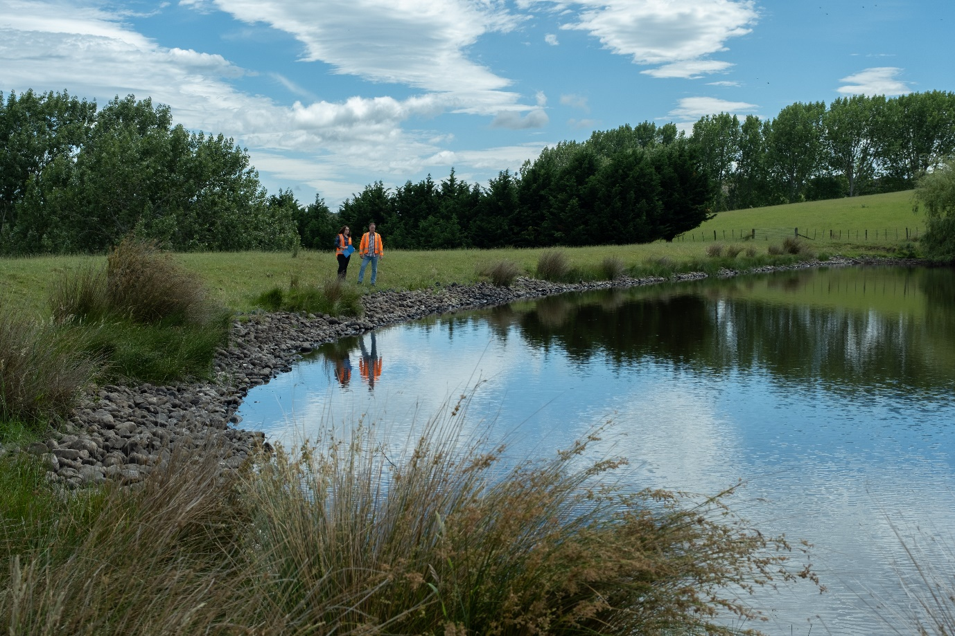
Farm, Wairarapa.

